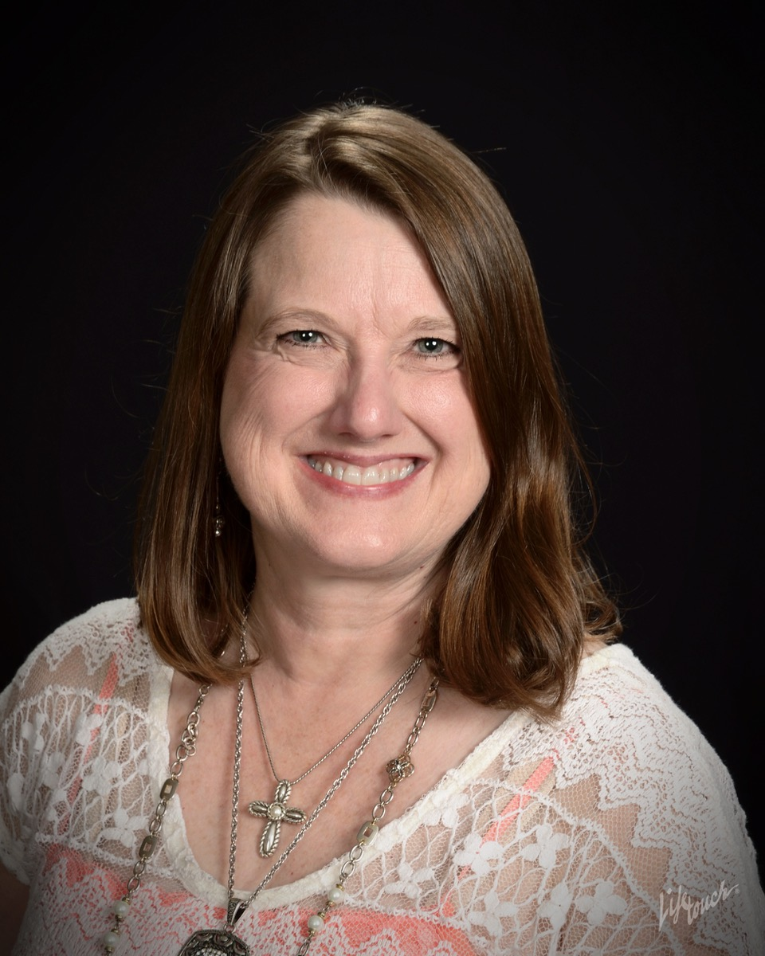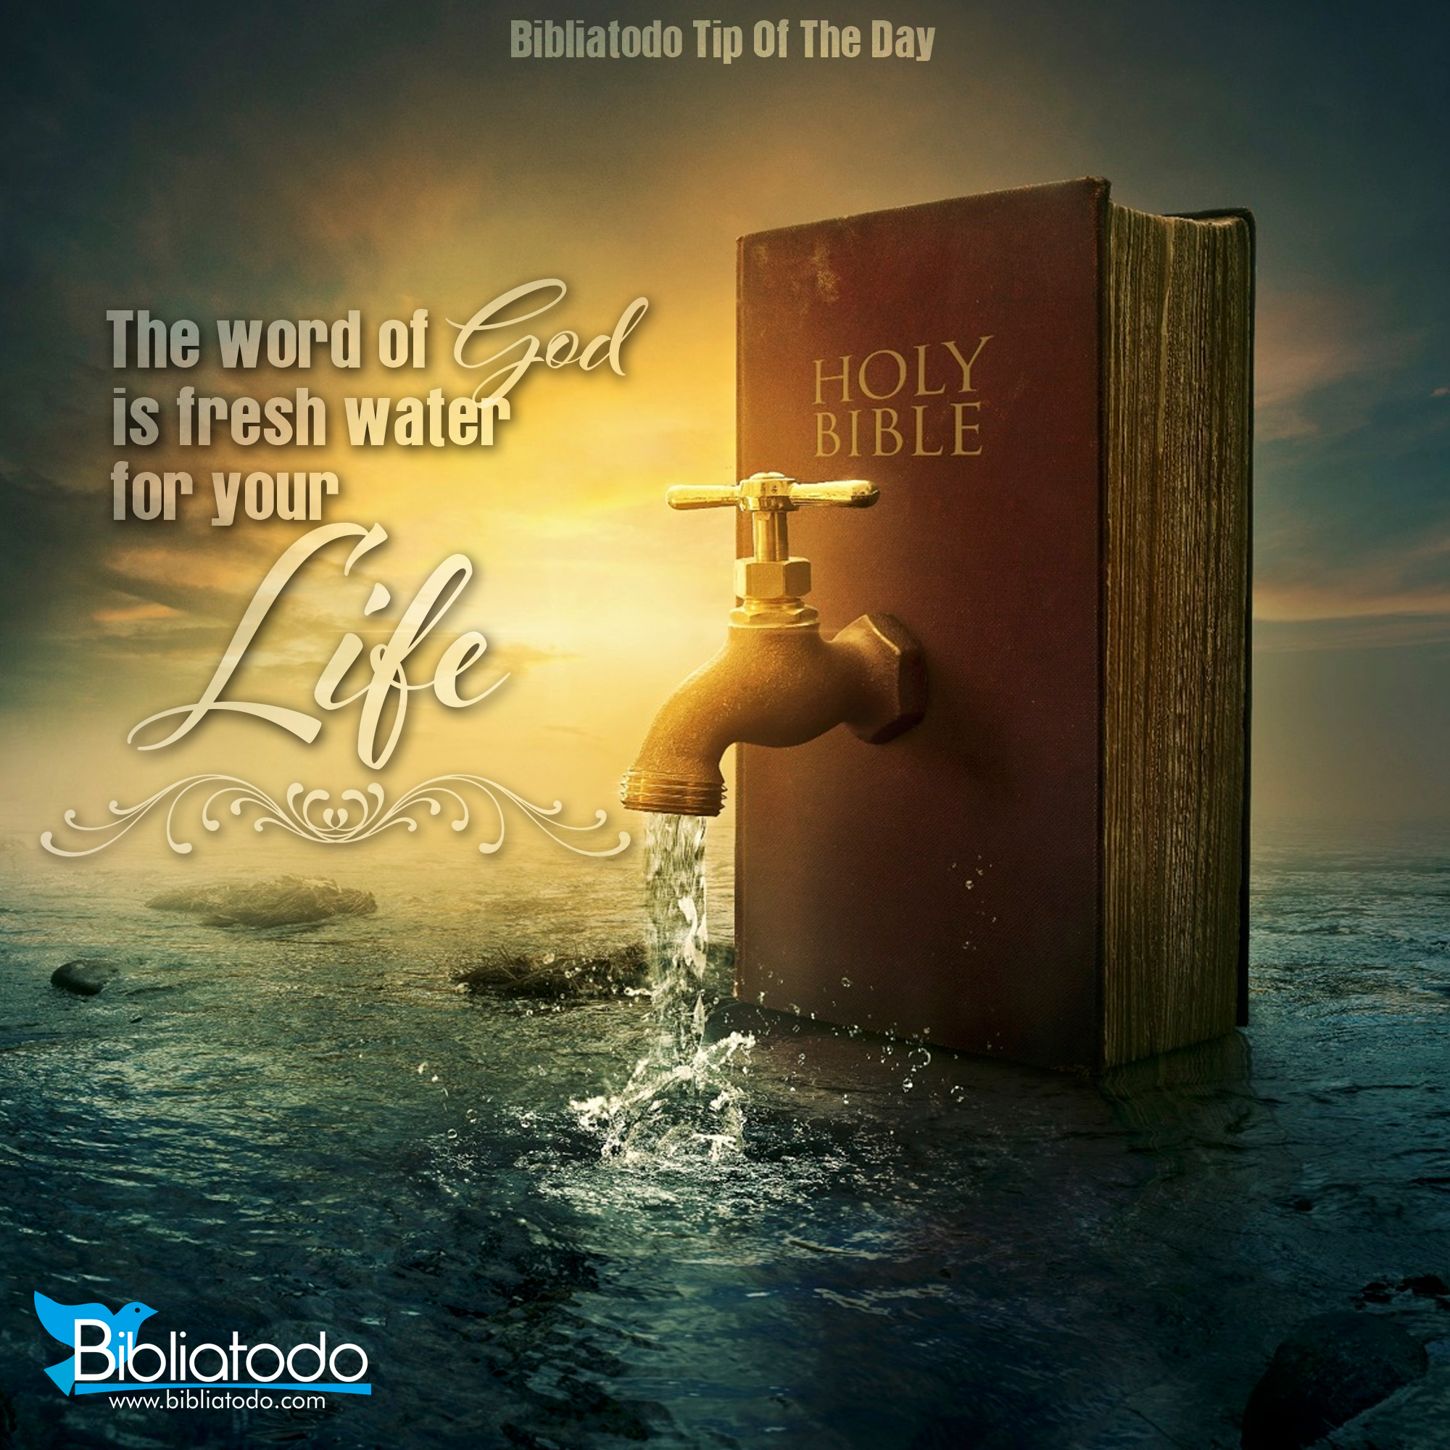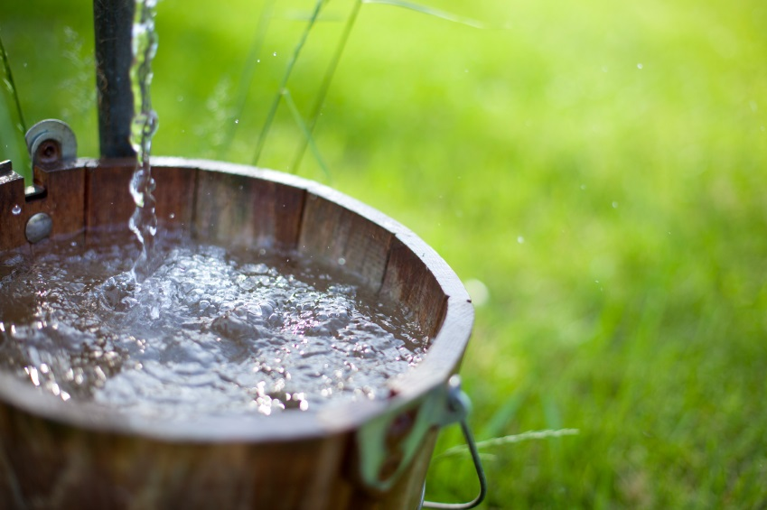

🙞 🙜

www.LoraJones.org

[www.facebook.com/LoraJones.org](http://www.facebook.com/LoraJones.org)

www.linkedin.com/in/lora-jones-22203848 ­

With nothing left of her former life, Lora began the long journey toward finding hope.

Today, Lora Jones is an inspirational speaker. Weaving the stories of Biblical characters with her own life story, she encourages others to renew their faith in God even in difficult circumstances. Her storytelling style enables her to communicate with people of differing backgrounds and denominations, and to audiences of all sizes.

Lora returned to her hometown, Liberal, Kansas, in 2007 to be closer to her extended families. She enjoys quiet mornings in her study chair with a cup of hot tea, long talks with good friends, and traveling across the country sharing the hope of Jesus to wounded hearts.

Lora Jones was born and raised on a farm near Liberal, Kansas. She earned an accounting degree from Kansas State University in 1986, but the best part of K-State was meeting her future husband, J. L. Jones. They married in 1985, and then furthered their education together at Midwestern Baptist Theological Seminary, completing their degrees in 1989. With school finally behind them, the young couple soon celebrated the birth of two children, Janessa and Jayden. Living in three states over their twenty years of marriage, J. L. and Lora served the Lord in full-time ministry until tragedy struck the family in 2004. An automobile accident claimed the lives of the entire family—except Lora.

March

29th - 31st

2019

Women’s Retreat

at

Oasis

Ranch

### Guest speaker

### Lora Jones

🙞 🙜

Bible

Toiletries

Towels and linens are provided

An extra blanket

Games

Snacks

Prior to leaving, groups of ladies will be put together and assigned a different meal to set up for and clean up after (so no one person has to do it all).

Oasis Ranch 23515 W Trail West Rd Plevna, KS 67568

**Friday the 29th**

6pm – Leave the church for Oasis Ranch

7pm – Dinner will be ready on Arrival

8:30pm – First Session

9:30pm – Free time/Bedtime

**Saturday the 30th**

8:30am – Breakfast

10:30am – Second Session

11:30am – Lunch prep and eat Lunch

1pm – 5:30pm – Free time/ Craft

6pm – Dinner

8pm – Third Session

9pm – Free time/ Bedtime

**Sunday the 31st**

8:30am – Breakfast

10:00am -11:30 - Praise and Worship

Fourth Session

12:00pm – Lunch

1:30 – Pack-up/ Cleanup

and head home

**Come To The Well**

**When your soul runs dry, how do you fill it?**

**When your life feels lonely where do you go?**

**When there is no one left who do you**

**Turn to? Join us on an**

**adventure with some**

**Biblical characters.**

**Their stories will lead us**

**to the answers we need from God’s own words.**

## Things to bring